2. AMALIY ISHI
Mavzu: Tarmoqda ko‘poqimlilik asosida ishlovchi dasturni yaratish

Ishning maqsadi:
Java dasturlash tili java.net.*, java.io.* va java.util.* paketlari klasslaridan foydalanib tarmoqda ko‘poqimlilik asosida ishlovchi dasturni yaratish.
Topshiriq:
Talaba Amaliy ishi uchun shaxsiy topshiriq oladi. Bu topshiriq bo‘yicha talaba tarmoqda ko‘poqimlilik asosida ishlovchi dasturni yaratadi. Har bir talaba uchun shaxsiy topshiriq 2.1- jadvalda berilgan.
Nazariy qism:
Thread klassi yordamida oqim yaratish:
class Multi extends Thread{
public void run(){
System.out.println("Oqim ishga tushdi...");
}
public static void main(String args[]){
Multi t1=new Multi();
t1.start();
}
}
NATIJA: Oqim ishga tushdi...

Runnable interfeysi asosida oqim yaratish:
class Multi3 implements Runnable{
public void run(){
System.out.println("Oqim ishga tushdi...");
}
public static void main(String args[]){
Multi3 m1=new Multi3();
Thread t1 =new Thread(m1);
t1.start();
}
}
Javada Sleep metodi
Thread klassining sleep() metodi oqimni qanchadir vaqtga uxlatish uchun foydalaniladi.
sleep() metodining sintaksisi:
- public static void sleep(long milliseconds) throws InterruptedException
- public static void sleep(long milliseconds, int nanos) throws InterruptedException

Misol:
class TestSleepMethod1 extends Thread{
public void run(){
for(int i=1;i<5;i++){
try{Thread.sleep(500);}
catch(InterruptedException e){System.out.println(e);}
System.out.println(i);
}
}
public static void main(String args[]){
TestSleepMethod1 t1=new TestSleepMethod1();
TestSleepMethod1 t2=new TestSleepMethod1();
t1.start();
t2.start();
}
}

Javada ThreadGroup
Java yagona obyektda bir nechta oqimlar guruhini ta’minlaydi.
Java thread group java.lang.ThreadGroup klassi asosida tadbiq etiladi.

2.1-jadval

ThreadGroup klassining konstruktorlari
Konstruktor | Tavsif
ThreadGroup(String name) | Berilgan nom bilan oqim guruhini yaratadi.
ThreadGroup(ThreadGroup parent, String name) | Berilgan ota-ona guruhi va nomi bilan oqim guruhini yaratadi.

2.2-jadval

ThreadGroup klassining muhim metodlari
Metod | Tavsifi
int activeCount() | Joriy guruhda ishlab turgan oqimlar sonini qaytaradi.
int activeGroupCount() | Joriy oqim guruhidagi faol guruhlar sonini qaytaradi.
void destroy() | Joriy oqim guruhi va barcha guruh ostilarni yoʻq qilish.
String getName() | Joriy guruh nomini qaytarish.
ThreadGroup getParent() | Joriy guruhning ota-onasini qaytarish.
void interrupt() | Joriy guruh oqimlarini toʻxtatish.
void list() | Joriy guruh ma’lumotlarini standart konsolga chiqarish.

- ThreadGroup tg1 = new ThreadGroup("Group A");
- Thread t1 = new Thread(tg1,new MyRunnable(),"bir");
- Thread t2 = new Thread(tg1,new MyRunnable(),"ikki");
- Thread t3 = new Thread(tg1,new MyRunnable(),"uch");
Yuqoridagi 3 ta oqim bitta guruhga tegishli. Bu yerda tg1 oqim guruhi nomi, MyRunnable Runnable interfeysidan tadbiq etilgan klass va "bir", "ikki" and "uch" oqim nomlari.
Barcha oqimlarini bitta qator bilan toʻxtatish mumkin.
- Thread.currentThread().getThreadGroup().interrupt();

ThreadGroup ga misol
public class ThreadGroupDemo implements Runnable{
public void run() {
System.out.println(Thread.currentThread().getName());
}
public static void main(String[] args) {
ThreadGroupDemo runnable = new ThreadGroupDemo();
ThreadGroup tg1 = new ThreadGroup("Parent ThreadGroup");
Thread t1 = new Thread(tg1, runnable,"bir");
t1.start();
Thread t2 = new Thread(tg1, runnable,"ikki");
t2.start();
Thread t3 = new Thread(tg1, runnable,"uch");
t3.start();
System.out.println("Oqim guruhi nomi: "+tg1.getName());
tg1.list();
}
}
2.3- jadval
Topshiriq variantlari
№ | Topshiriq
 | Ixtiyoriy sonni n darajaga ko‘tarish
 | Ixtiyoriy sonning kvadrat ildizini hisoblash
 | Ixtiyoriy n ta sondan eng kattasini topish
 | Ixtiyoriy n ta sondan eng kichigini topish
 | Ixtiyoriy kubning hajmini topish
 | Uchburchakning bissektrisa uzunligini topish
 | Ixtiyoriy n ta sonning yig’indisini hisoblash
 | Ixtiyoriy n ta sondan musbatlari yig’indisini hisoblash
 | Ixtiyoriy matnni teskari tartibda yozish
 | Ixtiyoriy matnning juft o‘rindagi haflarini ajratib yozish
 | Ixtiyoriy matnning toq o‘rindagi haflarini ajratib yozish
 | R radiusli shar hajmini hisoblash
 | Ixtiyoriy silindr hajmini hisoblash
 | To‘g’ri to‘rtburchak dioganalini hisoblab topish
 | R radiusli shar sirtining yuzini topish
 | Ixtiyoriy konus sirti yuzini topish
 | Ixtiyoriy n ta sondan juftlarini ajratib yozish
 | Ixtiyoriy n ta sonning o‘rta arifmetigini topish
 | Ixtiyoriy n ta sonning o‘rta geometrigini topish
 | Ixtiyoriy n faktorialni topish
 | Rombning yuzini topish
 | Ixtiyoriy n ta sonning o‘rta arifmetigini hisoblash
 | To‘g’ri to‘rtburchakning yuzini topish
 | Ixtiyoriy n ta sonning o‘rta geometrigini hisoblash
 | Uchburchakning yuzini hisoblash
 | Ixtiyoriy R radiusli aylana uzunligini topish
 | Ixtiyoriy R radiusli doira yuzini hisoblash
 | Ixtiyoriy koefitsentli kvadrat tenglama yechimini topish
 | Ixtiyoriy n ta sonni o‘sish tartibida saralash
 | Ixtiyoriy n ta sonni kamayish tartibida saralash

Ishni bajarish tartibi:
Ishni Eclipse yoki NetBeans IDE integrallashgan ishlab chiqarish muhitini yuklash bilan boshlaymiz.
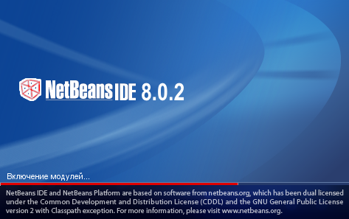
2.1- rasm. NetBeans IDE ishga tushish jarayoni

Quyidagi rasmda NetBeans IDE muhitining asosiy darchasi yuklangan.
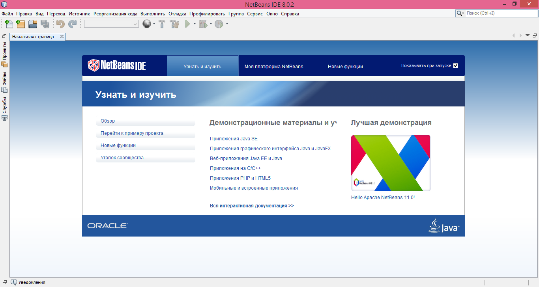
2.2- rasm. NetBeans IDE muhiti asosiy darchasi
Shundan so‘ng “Файл” menyusidan “Создать проект” bo‘limi tanlanganda quyidagi rasmdagi darcha paydo bo‘ladi. Ushbu darchadan “Категории” bo‘limidan Java tanlanib “Далее” tugmasi bosiladi.
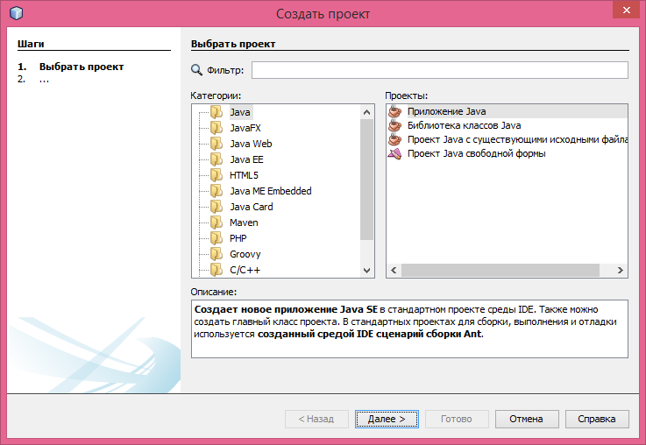
2.3- rasm. NetBeans IDE “Создать проект” darchasi

Keyingi qadam “Новый Приложение Java” dasturiga o‘tiladi. Ushbu darchaning “Имя проекта” maydoniga proyekt nomi sifatida “Talabaning_Ismi” kiritilib, “Расположение проекта” maydoniga proyekt saqlanishi lozim bo‘lgan joy tanlanib, “Создать главный класс” dan galochka olib tashlanib “Готово” tugmasi bosiladi.
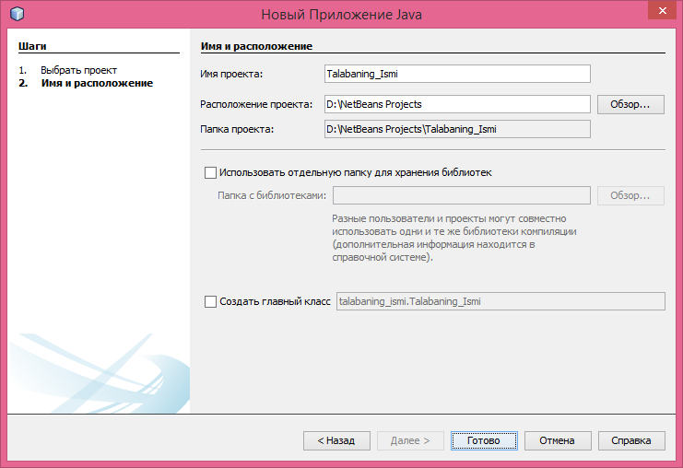
2.4- rasm. NetBeans IDE muhiti “Новый Приложение Java” darchasi
So‘ng yaratilgan loyihaning ustiga sichqonchaning o‘ng tugmasi bir marta bosiladi va paydo bo‘lgan kontekst menyudan “Новый → Класс Java” tanlanadi.
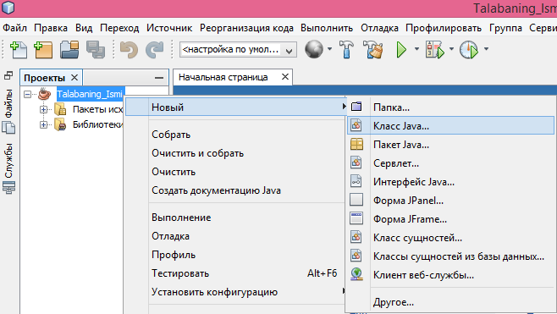
2.5- rasm. NetBeans IDE muhiti yangi klass yaratish

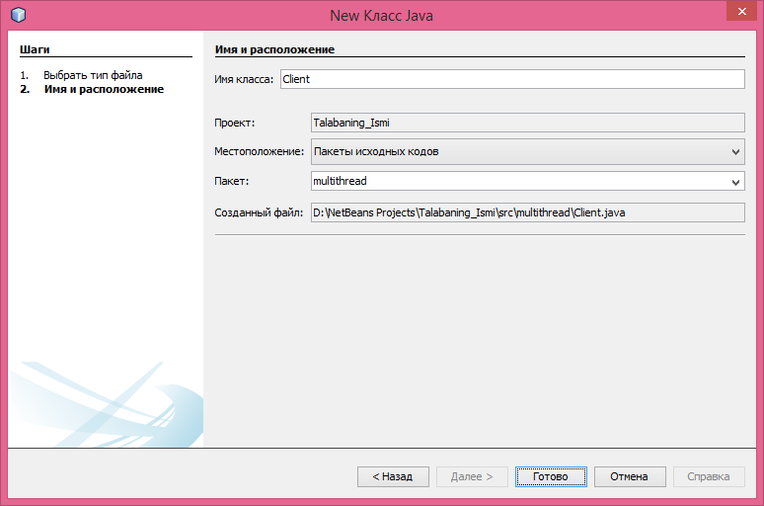
2.6- rasm. NetBeans IDE muhiti “New Класс Java” darchasi

“New Класс Java” darchasining “Имя класса” maydoniga “Client”, “Пакет” maydoniga “multithread” kiritilib “Готово” tugmasi bosiladi. Yaratilgan Client.java fayliga quyidagi Java kodi kiritiladi.
package multithread;
import java.io.*;
import java.net.*;
import java.util.*;
public class Client {
private static InetAddress host;
private static final int PORT = 1234;
public static void main(String[] args) {
try {
host = InetAddress.getLocalHost();
} catch (UnknownHostException uhEx) {
System.out.println("\nID host topilmadi!\n");
System.exit(1);
}
sendMessages();
}
private static void sendMessages() {
Socket socket = null;
try {
socket = new Socket(host, PORT);
Scanner networkInput = new Scanner(socket.getInputStream());
PrintWriter networkOutput = new PrintWriter(socket.getOutputStream(), true);
Scanner userEntry = new Scanner(System.in);
String message, response;
do {
System.out.print("\nXabarni kiriting (Chiqish uchun 'Q'): ");
message = userEntry.nextLine();
networkOutput.println(message);
response = networkInput.nextLine();
System.out.println("SERVER> " + response);
} while (!message.equals("Q"));
} catch (IOException ioEx) {
ioEx.printStackTrace();
} finally {
try {
System.out.println("\nBog'lanish uzildi…");
socket.close();
} catch (IOException ioEx) {
System.out.println("Bog'lanish uzilmadi!");
System.exit(1); } } }}

Shu kabi Server.java fayli yaratiladi va quyidagi Java kodi kiritiladi.
package multithread;
import java.io.*;
import java.net.*;
import java.util.*;
public class Server {
private static ServerSocket serverSocket;
private static final int PORT = 1234;
public static void main(String[] args)
throws IOException {
try {
serverSocket = new ServerSocket(PORT);
System.out.println("\nServer soket ishga tushdi...\nKliyentni kutmoqda...");
} catch (IOException ioEx) {
System.out.println("\nPortni o‘rnata olmadim!");
System.exit(1);
}
do {
Socket client = serverSocket.accept();
System.out.println("Yangi kliyent qabul qilindi.");
ClientHandler handler = new ClientHandler(client);
handler.start();
} while (true); }}
class ClientHandler extends Thread {
private Socket client;
private Scanner input;
private PrintWriter output;
public ClientHandler(Socket socket) {
client = socket;
try {
input = new Scanner(client.getInputStream());
output = new PrintWriter(client.getOutputStream(), true);
} catch (IOException ioEx) {
ioEx.printStackTrace();
} }
public void run() {
String received;
do {
received = input.nextLine();
output.println("AKS-SADO: " + received);
//Repeat above until 'QUIT' sent by client…
} while (!received.equals("Q"));
try {
if (client != null) {
System.out.println("Bog'lanish uzildi");
client.close();
}
} catch (IOException ioEx) {
System.out.println("Bog'lanish uzilmadi!");
}
}
}

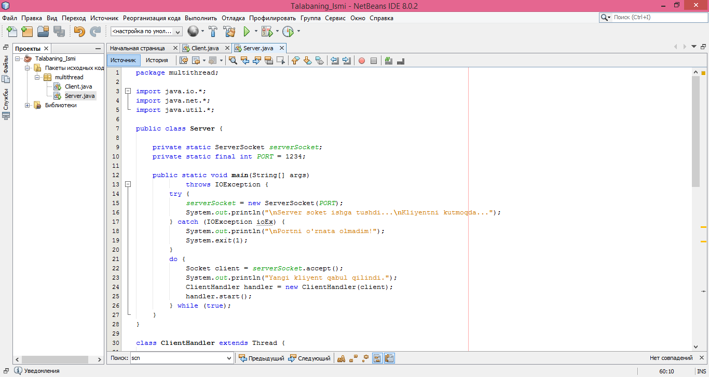
2.7- rasm. NetBeans IDE muhiti Client.java va Server.java fayllari

Tarmoq dasturini ishga tushirish Server.java klassidan boshlanadi. Buning uchun Server.java fayli ustiga sichqonchaning oʻng tugmasi bosiladi va paydo boʻlgan kontekst menyudan “Выполнить файл” tanlanadi. Shu kabi Client.java fayli ishga tushiriladi.

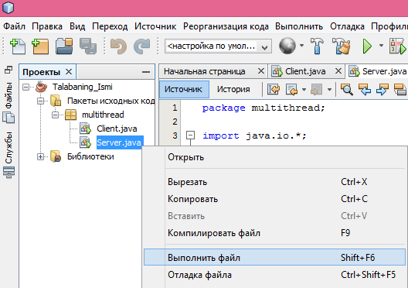
2.8- rasm. NetBeans IDE muhiti Server.java ni ishga tushirish

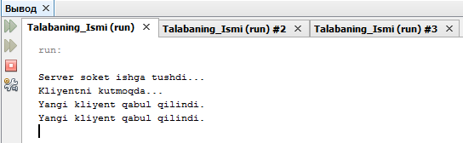
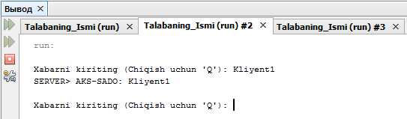
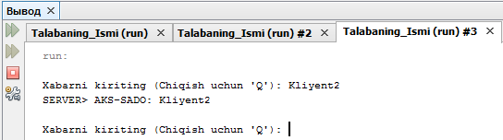
2.9- rasm. NetBeans IDE muhiti natija darchalari

Nazorat savollari
- java.net.* paketi.
- java.io.* paketi
- java.util.* paketi
- Thread klassi.
- Runnable interfeysi.
- Sleep metodi.
- ThreadGroup klassi.
- InputStream klassi.
- OutputStream klassi.

